Settlement & Reconciliation
# Source: AI Source: Provided by: [Data Path: Persons Table -> ID Column: 1, Name_En Column: Motasem Essam] -> From: [ChatGPT] on [1/21/2026]
Once a payment is successfully made, the final (and very important) step in the flow is settlement and reconciliation. These are financial operations that ensure:
- You receive the money into your business bank account (settlement).
- You match and verify that every transaction recorded in your system matches the bank’s official reports (reconciliation).

✅ 1. What is Settlement?
# Source: AI Source: Provided by: [Data Path: Persons Table -> ID Column: 1, Name_En Column: Motasem Essam] -> From: [ChatGPT] on [1/21/2026]
Settlement is the process by which funds from a successful transaction are actually transferred to your bank account by the acquiring bank (the bank you integrated with).

🔄 Example:
# Source: AI Source: Provided by: [Data Path: Persons Table -> ID Column: 1, Name_En Column: Motasem Essam] -> From: [ChatGPT] on [1/21/2026]
- A user pays EGP 500 on Monday.
- The bank processes and settles that payment to your account by Wednesday (e.g., after 1–2 business days).

Key Settlement Terms:
# Source: AI Source: Provided by: [Data Path: Persons Table -> ID Column: 1, Name_En Column: Motasem Essam] -> From: [ChatGPT] on [1/21/2026]
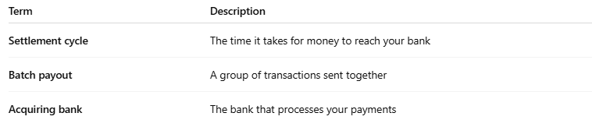
Term | Description
Settlement cycle | The time it takes for money to reach your bank
Batch payout | A group of transactions sent together
Acquiring bank | The bank that processes your payments

📊 2. What is Reconciliation?
# Source: AI Source: Provided by: [Data Path: Persons Table -> ID Column: 1, Name_En Column: Motasem Essam] -> From: [ChatGPT] on [1/21/2026]
Reconciliation means comparing:
- Your internal transaction records (from your app/database)
- With the official bank report or settlement file
You’re checking:
- Were all successful transactions actually settled?
- Were any amounts short, failed, or overcharged?
- Were refunds and chargebacks processed correctly?

🔧 Reconciliation Process (Step by Step)
# Source: AI Source: Provided by: [Data Path: Persons Table -> ID Column: 1, Name_En Column: Motasem Essam] -> From: [ChatGPT] on [1/21/2026]
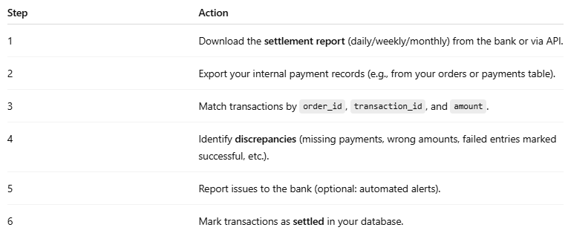
Step | Action
1 | Download the settlement report (daily/weekly/monthly) from the bank or via API.
2 | Export your internal payment records (e.g., from your orders or payments table).
3 | Match transactions by order_id, transaction_id, and amount.
4 | Identify discrepancies (missing payments, wrong amounts, failed entries marked successful, etc.).
5 | Report issues to the bank (optional: automated alerts).
6 | Mark transactions as settled in your database.

🔒 Why Is This Important?
# Source: AI Source: Provided by: [Data Path: Persons Table -> ID Column: 1, Name_En Column: Motasem Essam] -> From: [ChatGPT] on [1/21/2026]
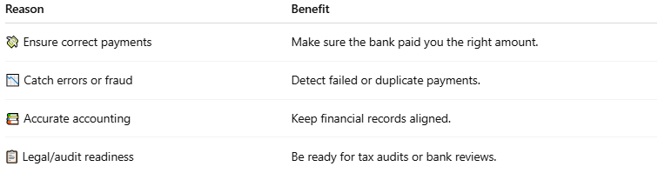

Reason | Benefit
💸 Ensure correct payments | Make sure the bank paid you the right amount.
📉 Catch errors or fraud | Detect failed or duplicate payments.
📚 Accurate accounting | Keep financial records aligned.
📋 Legal/audit readiness | Be ready for tax audits or bank reviews.

📦 What Data Should Be Tracked?
# Source: AI Source: Provided by: [Data Path: Persons Table -> ID Column: 1, Name_En Column: Motasem Essam] -> From: [ChatGPT] on [1/21/2026]
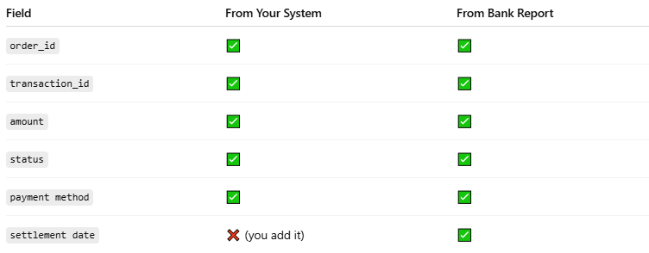

Field | From Your System | From Bank Report
order_id | ✅ | ✅
transaction_id | ✅ | ✅
amount | ✅ | ✅
status | ✅ | ✅
payment method | ✅ | ✅
settlement date | ❌ (you add it) | ✅

🛠️ Automation Tools You Can Use
# Source: AI Source: Provided by: [Data Path: Persons Table -> ID Column: 1, Name_En Column: Motasem Essam] -> From: [ChatGPT] on [1/21/2026]
- Scheduled tasks (cron jobs) to pull bank reports daily.
- Database scripts to match transactions and flag mismatches.
- Log mismatches into a dashboard for finance/admin teams.
- Send email reports or Slack alerts on issues.

📌 Summary
# Source: AI Source: Provided by: [Data Path: Persons Table -> ID Column: 1, Name_En Column: Motasem Essam] -> From: [ChatGPT] on [1/21/2026]
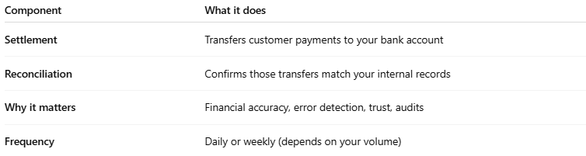

Component | What it does
Settlement | Transfers customer payments to your bank account
Reconciliation | Confirms those transfers match your internal records
Why it matters | Financial accuracy, error detection, trust, audits
Frequency | Daily or weekly (depends on your volume)

